AI-Based Code Completion: Working with suggestions for classes, loops, conditionals

Name:V.Prapul Kumar

Roll no:2503A52377

Batch:13
Task Description #1 (AI-Based Code Completion for Loops)
Task: Use an AI code completion tool to generate a loop-based program.

Prompt:
Generate Python code to print all even numbers between 1 and N using a loop.
Code:
# Print all even numbers between 1 and N

n = int(input("Enter the value of N: "))

for number in range(1, n + 1):
# Check whether the number is even
if number % 2 == 0:

print(number, end=" ")
Output:

Justification:
The program uses a for loop to check every number from 1 to N. The % operator identifies even numbers because an even number gives a remainder of 0 when divided by 2. The program was validated with N = 20, producing all even numbers from 2 to 20 correctly.
Task Description #2 (AI-Based Code Completion for Loop with Conditionals)
Task: Use an AI code completion tool to combine loops and conditionals.

Prompt:
Generate Python code to count how many numbers in a list are even and odd using a loop and if condition.

Code:
# Count even and odd numbers in a list

numbers = [12, 7, 4, 9, 16, 21, 8, 5]

even_count = 0
odd_count = 0

# Check each number in the list
for number in numbers:
if number % 2 == 0:
even_count += 1
else:
odd_count += 1

print("Numbers:", numbers)
print("Even numbers:", even_count)

print("Odd numbers:", odd_count)
Output:
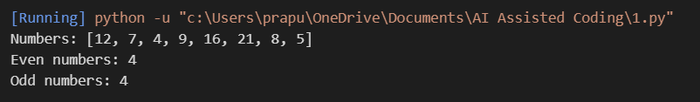

Justification:
The program uses a for loop to examine each number in the list. The if-else condition checks whether each number is divisible by 2. If the remainder is 0, the even count is increased; otherwise, the odd count is increased. For the given list, the program correctly identifies 4 even numbers and 4 odd numbers.

Task Description #3 (AI-Based Code Completion for Class Attributes Validation)

Task: Use an AI tool to complete a Python class that validates user input.
Prompt:
Generate a Python class User that validates age and email using conditional statements. Include simple test cases for valid and invalid inputs.

Code:
class User:
def __init__(self, age, email):
self.age = age
self.email = email

def validate(self):
# Check whether the age is valid
if self.age >= 18:
age_valid = True
else:
age_valid = False

# Check whether the email contains basic required symbols
if "@" in self.email and "." in self.email:
email_valid = True
else:
email_valid = False

return age_valid, email_valid

# Test cases
users = [
User(20, "user@gmail.com"),
User(16, "invalidemail")
]

for user in users:
age_valid, email_valid = user.validate()

print("\nAge:", user.age)
print("Email:", user.email)
print("Age valid:", age_valid)
print("Email valid:", email_valid)

Output:
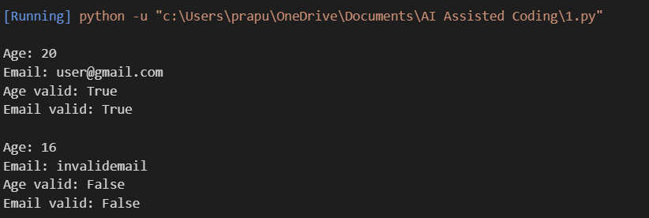

Justification:
The User class validates both age and email using conditional statements. The age is considered valid when it is 18 or above, while the email is checked for the presence of @ and .. The test cases verify both valid and invalid inputs, and the program correctly identifies them.

Task Description #4 (AI-Based Code Completion for Classes)
Task: Use an AI code completion tool to generate a Python class for managing student details.

Prompt:
Generate a Python class Student with name, roll number, and marks attributes, with methods to calculate total and average marks.
Code:
class Student:
def __init__(self, name, roll_number, marks):
self.name = name
self.roll_number = roll_number
self.marks = marks

# Calculate the total marks
def calculate_total(self):
return sum(self.marks)

# Calculate the average marks
def calculate_average(self):
return self.calculate_total() / len(self.marks)

# Create a student object
student = Student("Prapul", 101, [85, 78, 92, 88])

print("Student Name:", student.name)
print("Roll Number:", student.roll_number)
print("Marks:", student.marks)
print("Total Marks:", student.calculate_total())
print("Average Marks:", student.calculate_average())
Output:
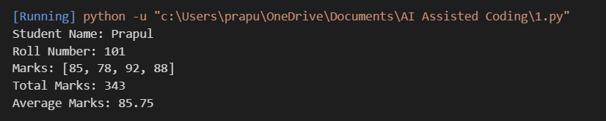

Justification:
The Student class correctly stores the student's name, roll number, and marks as attributes. The calculate_total() method calculates the sum of all marks, while calculate_average() calculates the average using the total and number of subjects. The test student confirms that both methods work correctly.

Task Description 5 (AI-Assisted Code Completion Review)
Task: Use an AI tool to generate a complete Python program using classes, loops, and conditionals together.

Prompt:
Generate a simple Python bank account system using a class, loops, and conditional statements. Include deposit, withdrawal, balance checking, and a simple menu.

Code:
class BankAccount:
def __init__(self, name, balance=0):
self.name = name
self.balance = balance

def deposit(self, amount):
if amount > 0:
self.balance += amount
print("Amount deposited successfully.")
else:
print("Invalid deposit amount.")

def withdraw(self, amount):
if amount > 0 and amount <= self.balance:
self.balance -= amount
print("Amount withdrawn successfully.")
else:
print("Insufficient balance or invalid amount.")

def check_balance(self):
print("Current Balance:", self.balance)

# Create a bank account
account = BankAccount("Prapul", 5000)

# Menu-driven system using a loop
while True:
print("\n1. Deposit")
print("2. Withdraw")
print("3. Check Balance")
print("4. Exit")

choice = input("Enter your choice: ")

if choice == "1":
amount = float(input("Enter deposit amount: "))
account.deposit(amount)

elif choice == "2":
amount = float(input("Enter withdrawal amount: "))

Output:
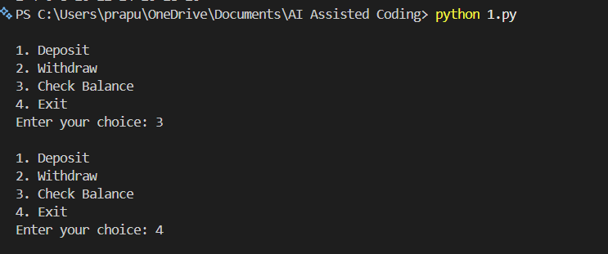

Justification:
The program demonstrates how AI can combine classes, loops, and conditional statements in one application. The BankAccount class manages the account and its balance, the while loop repeatedly displays the menu, and if-elif-else statements process the user's choice. The program also validates deposits and withdrawals, showing both the usefulness and the need to review AI-generated code for correct logic.

